3.2 Project: Abstraction, Constructors, & Access Specifiers
Christopher Crayton
ECPI University
SDC330L: Advanced Object-oriented Programming Using Java LAB
Dr. Helio de Castro
August 9, 2026

3.2 Project: Abstraction, Constructors, & Access Specifiers
Backend Design
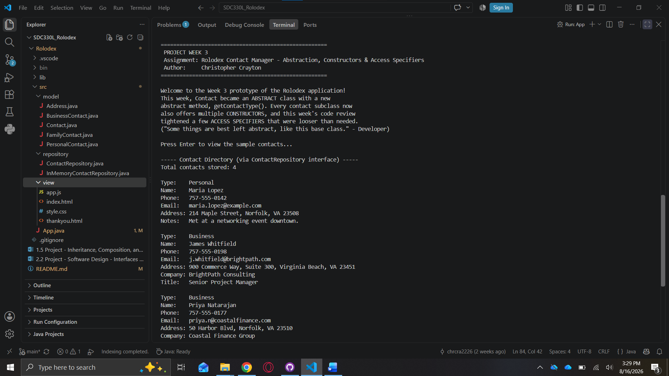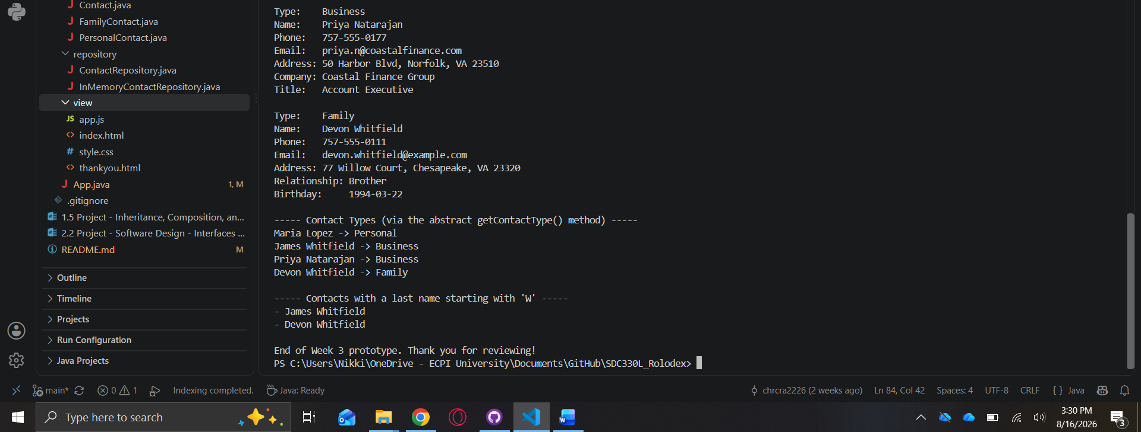

GUI Design
